Small & Medium Enterprise Administration, MOEA
Startup Terrace Residency Application Form
經濟部中小企業處
林口新創園
進駐申請書

Revised Edition in July 2019
- Method of application申請方式
Applications will be reviewed on a rolling basis. When all residency spaces are filled up in full, nevertheless, an applicant may be waitlisted.
隨時受理申請。惟若進駐空間已滿時，得排入後續申請等候名單。
For application requirements, please refer to Application Guide for Residency in Startup Terrace.
申請資格請詳見「林口新創園進駐申請須知」。
The application documents shall be sent by mail or in person to the Project Office, together with the E-mail attaching the electronic file to be sent to: hello@startupterrace.tw; Foreign companies shall apply by submitting the documents via E-mail. The subject of the E-mail shall be unified as: Residency Application in Linkou Startup Terrace - ○○○○ Company.
申請文件應函送或親送本專辦，並E-mail電子檔至：hello@startupterrace.tw；外國公司採 E-mail 方式送件申請。寄件主旨請統一為：林口新創園進駐申請-○○○○公司。
- Supporting documents required for application
申請應備資料
- Residency Application Form (Cf. Appendix I annexed hereto)
進駐申請書(如附件一)
- Declaration (Cf. Appendix II annexed hereto)
聲明書(如附件二)
- A hard copy of company's profit-seeking enterprise registration certificate or certificate of commercial registration (A startup company ready to be incorporated is exempted from those papers)
公司營利事業登記證影本或商業登記證明文件影本。 (即將設立之新創事業可免附)
- Please submit the aforementioned documents in hard copies in triplicate.
上列資料請繳交紙本，一式三份。
- If the applying firm is notified by the Project Office to submit a supplement of the proposal, please fill out the form in Appendix IV.
如經專案辦公室通知須提交提案計畫書補充之申請單位請依附件四格式填寫 。

- Location for delivery送件地點
Address: (24449) 19th Floor, No. 502, Section 2, Ren'ai Road, Linkou District, New Taipei City
地址：(24449)新北市林口區仁愛路2段502號19樓
Recipient: Linkou Startup Terrace (Residency application)
收件人：林口新創園(進駐申請)
E-mail: hello@startupterrace.tw

- Review Mechanism of application for residency/extension進/延駐審議機制
- Scheduled time for residency/extension application
進/延駐審議時程
Applications will be accepted at any time, and the Review Team and the Review Committee will hold meetings for review in March, June, September and November of each year. Ad hoc meetings may also be held if the Project Office deems it necessary.
隨時受理申請，並於每年度之3、6、9、11月份召開進駐評選工作小組及審議委員會進行審查，如本專辦認有必要時，亦得召開臨時會議。
- Flowchart for residency/extension application review
進/延駐審議流程
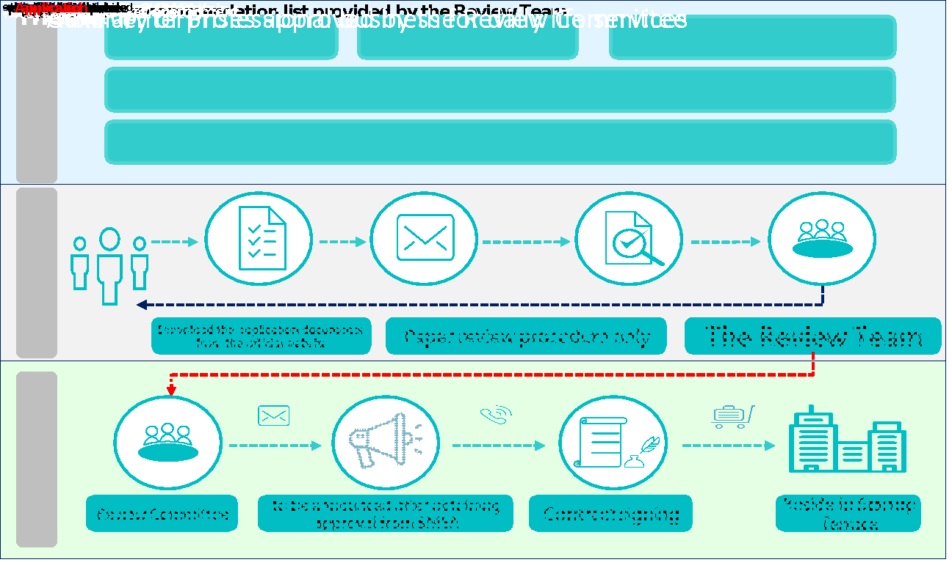

- Qualifications review資格審查
- Required documents verification要件檢定:
The Project Office will check whether all the necessary documents are complete. If there are any omissions, the Project Office may notify the applicant to submit the supplement documents before a deadline. The application will be reviewed only after the documents are complete and ready.
由本專辦查核各項應備文件是否齊全，如有所缺漏，本專辦得通知申請者限期補件，待應備文件備妥後，始行進駐審查程序。
- Qualification verification資格檢定:
After confirming the applicant's qualifications and documents, the Project Office will conduct a preliminary evaluation based on the number of persons residing for suppliers, reasonable use of space, legality (including but not limited to land use zoning regulations) and safety. Applications that pass the preliminary evaluation will be submitted for review; applications that do not pass will be returned.
確認申請者之資格及文件後，由本專辦依廠商進駐人數、空間使用合理性、合法性(包含但不限於土地使用分區規定)及安全性進行初審，通過後提請進行審議，不通過者退回申請。

- The Review Team / The Review Committee
評選工作小組委員會/審議委員會
A firm that intends to apply for residency shall apply in accordance with the regulations, and the Project Office will invite the Review Committee comprising external professional consultants and experts to conduct the deliberation. The review focuses on:
欲申請進駐企業依規定提出進駐申請，由本專辦邀請外部專業顧問、業師所籌設之審議委員會進行進駐審議。審議重點為：
- To evaluate the applicant's operating capability and development potential.
評估進駐企業經營能力及發展潛力。
- To evaluate the applicant's expertise or product life cycle and its competitive edge in the markets.
評估進駐企業技術或產品生命週期及市場競爭力。
- To evaluate the applicant's core know-how or the marketing strategy feasibility of the key products.
進駐企業其核心技術或主力產品之行銷策略應具可行性。
- To evaluate the applicant's capability in financial planning.
- 評估進駐企業財務規劃能力。

Appendix I. Residency Application Form

林口新創園進駐申請書
STARTUP TERRACE Residency Application Form
申請資格類別/ Qualifications
□ 新創事業 Startup
□ 國際加速器 International Accelerator
□ 創業人才培訓事業 Entrepreneurship Development Organization
□ 生活服務之輔助性事業或專業服務之事業 Business service or professional oriented business
□ 其他 Other：_______________________________________

一、申請公司或團隊基本資料/ Applicant Basic Information
公司中英文名稱  Company Name  (Chinese and English) | (中文)
公司中英文名稱  Company Name  (Chinese and English) | (English)
公司登記地址
Company Address
通訊地址
Mailing Address
公司電話
Company Phone No.
公司統一編號Incorporation Registration No. |  | 公司成立日期  Date Established
負責人  Principal |  | 性別  Gender | □男Male  □女Female
身分證字號/護照號碼 ID No./Passport No. |  | 性別  Gender | □男Male  □女Female
出生日期  Date of Birth |  | E-mail
聯絡人  Contact Person |  | 職稱  Position
E-mail |  | 連絡電話  Telephone No.
實收資本額  Paid-in-Capital | NT$ | 前一年度營業額  Sales revenues in the preceding year | NT$

二、公司或團隊營運計畫/ Business Plan
公司/團隊簡介
（200字內，需含核心技術/產品描述）
Summary on the company/team (Including the core know-how/illustration on products, not beyond the maximum of 200 characters)
公司/團隊成員簡介（200字內，包含組織架構、人力運用、成員經歷等）
Profile of the Company/ the team member (Including organizational structure, member configuration, member experience, etc. (Not beyond the maximum of 200 characters)
近一年內公司經營規劃(包含公司之願景、定位、 營運構想、經營策略) （200字內）
The company's business plan for the past year (including the company's vision, positioning, operational concept, business strategy) (Not beyond the maximum of 200 characters)
得獎經歷/特殊榮耀
Highlights of awards/extraordinary honors
說明公司的商業模式及營業項目與林口新創園的鏈結性，或可提供何種相關數據供林口新創園使用（200字內）Describe the company's business model and the connection between the business project and Linkou Startup Terrace, or what kind of relevant data can be provided for the Linkou Startup Terrace
公司/團隊使用之雲端服務平台  Cloud service platform used by your company/team | □ Amazon Web Services (AWS)  □ Google Cloud Platform (GCP)  □ Microsoft Azure  □ 其他 Others：________________________  □ 無使用 Unused
主要產品服務領域別  Field of your product or service  (至多兩項 At the most 2 fields) | □ 人工智慧&大數據 AI & Big Data  □ 虛擬實境AR/ 虛擬實境VR/ 混合實境MR  □ 5G 技術/應用 5G Technology/Applications  □ 消費性電子 Consumer Electronics  □ 金融科技、區塊鏈&電子商務  Fintech, Blockchain & E-Commerce  □ 軟體服務 Software service  □ 硬體服務 Hardware service  □ 物聯網 IoT  □ 智慧醫療&生物科技 Smart Health & Biotech  □ 資訊安全技術 Cyber Security  □ 綠能科技 Green Tech  □ 其他 Others：____________________________

三、申請空間類別/ Space
空間類別 Space | 空間大小(坪)/席數  Space Size/Seats | 進駐人數  Number of Team Members
□共同工作空間  Co-working Space | 席數 Seats：
□獨立辦公空間  Independent Office | □ 15坪以下 15 ping or less  (建議2-4人 2-4 people recommended)  □ 20坪-29坪 20 ping ~29 ping or less  (建議5-7人 5-7 people recommended)  □ 30坪-39坪 30 ping ~39 ping or less  (建議8-12人 8-12 people recommended)  □ 40坪-49坪 40 ping ~49 ping or less  (建議13-15人 13-15 people recommended)
□整層辦公室  Whole floor office | 約265坪 (Appr.265 pings)
□營業空間  Store Space | □ 30-40坪 (30-40 pings)  □ 41-50坪 (41-50 pings)  □ 60-70坪 (60-70 pings)
預定進駐期間  Anticipated Period | _____年___月___日至_____年___月___日  (yyyy / mm / dd to yyyy / mm / dd)
空間使用說明
(請具體說明)
The plan of how to use the space (Please describe it specifically)

- 承諾書/ Letter of Acknowledgement
申請人茲此聲明，本公司進駐後所從事之研發產品/ 服務/ 營運等，不侵害他人專利權、專門技術及著作權等相關智慧財產權，並保證本申請書及所檢附之文件或所作之陳述，均屬實正確，如有任何造假情勢，願負一切法律責任。
The Undersigned Applicant hereby formally and solemnly declares that the plan covered under the Application does not at all infringe upon another in patent, expertise, copyright and such intellectual property rights and further undertakes and guarantees that the Application, the submitted documents and all statements provided herein are absolutely correct. In case of misrepresentation, the Undersigned Applicant agrees to assume all sorts of legal responsibilities in full.

申請人簽名/蓋章/日期： 公司及負責人印章：
(Signed with seal by the Applicant/Date) (Signature of principal and company seals)

公司及負責人印章
申請人簽名/蓋章/日期

Appendix II. Letter of Declaration

Startup Terrace LETTER OF DECLARATION
林口新創園 聲明書
I, the Undersigned Declarants, hereby formally and solemnly come to this affidavit commitment and apply for residency into Startup Terrace. I hereby declare that all the statements as enumerated below are absolutely true and authentic without misrepresentation:
茲切結申請進駐林口新創園，本人聲明下列事項均屬確實：
- That I leave no payable tax outstanding and unpaid.
無欠繳應納稅捐尚未繳清之情事。
- That over the past three years, I have not received a penalty with suspension from the rights due to implementation of the government projects without a fact that such period of suspension has not yet expired.
三年內未曾有因執行政府計畫受停權處分而其期間尚未屆滿之情事。
- That over the past one year, I have not committed an act in contravention of protection over laborers, environment related laws or requirements to protect interests of the mentally and physically handicapped people under “People with Disabilities Rights Protection Act”.
一年內未曾有違反保護勞工、環境相關法規或違反身心障礙者權益保障法相關規定。
- Does the Declarant have a record with abnormal credit standing in negotiable instruments or liabilities?
是否有票、債信異常之情事
□ No. 否。
□ Yes. Please specify the reasons:
______________________________________.
- Is the enterprise in this application actually the same person or a related party (enterprise) as another applicant or an enterprise under coaching concerning the credit limit in one single case under the Operational Guidelines for Startup Terrace?
是否有林口新創園作業要點關於個案額度有關與其他申請人或受輔導企業具有同一人或關係人（企業）之狀態。
□ No否。
□ Yes. Please elaborate是，說明如下：
______________________________________.
- Has the enterprise in this application been financially supported by a juristic person shareholder?
申請企業是否已獲法人股東資金挹注
□ No否。
□Yes. Name of the juristic person shareholder: _________, with the investment in the amount of NT$_________.
是，法人股東名稱：_________，投資新臺幣_______元。
- Has the enterprise in this application had its parent company?
申請企業是否已有母公司
□ No否。
□ Yes. Name of its parent company是，母公司名稱：
___________________________________
- Has the enterprise in this application earned a profit yet?
申請企業目前是否已獲利
□ No否。
□ Yes是。

- Does the applicant serve as the responsible person of another enterprise?
申請人是否擔任其他企業負責人
□ No否。
□ Yes. Name of the enterprise 是，企業名稱：
___________________________________

The Undersigned Declarant hereby consents that, before this application is approved, whenever the fact contained in the aforementioned declaration changes, the Declarant shall keep the Project Office informed in writing forthwith. In case of misrepresentation in the statement or accounts or failure to make a notification as required, the Project Office of Linkou Startup Terrace may reject the application or terminate the agreement and further retrieve the coaching funds already appropriated and paid. The Declarant shall also assume all legal responsibilities resulting therefrom, without objections whatsoever. This Declarant has hereby solemnly declared as above.
聲明人同意在本申請案獲得核准前，如上述聲明之事實已有變動者，應立即以書面通知林口新創園專案辦公室；如有聲明或說明不實、或應通知事項而未通知者，林口新創園專案辦公室得駁回申請或解除合約，並追回已撥付之輔導資金，並由聲明人承擔衍生的相關法律責任，絕無異議，特此聲明。

Signature of the responsible person:
負責人簽名：
___________________________________

Affixed with the official seal of the responsible person:
負責人印章：
___________________________________

Affixed with the official seal of the enterprise:
企業印章：
___________________________________

Date: ___________, 20__

Appendix III. Residency Extension/Withdrawal Application Form

林口新創園團隊延駐/離駐申請表
STARTUP TERRACE’s Residency Extension/Withdrawal Application Form
團隊名稱
Name of Team
申請項目  Application for | □延駐Extension of Residency  □中途離駐Halfway Withdrawal  □期滿離駐Withdrawal
事由及原因
（請簡述）
Cause(s) and Reasons(s) (Please give a brief description)
團隊代表：
Team Representative：

Appendix IV. Format of the Business Plan

Small & Medium Enterprise
Administration, MOEA
Startup Terrace

＜Company name＞
Business Plan

經濟部中小企業處

林口新創園

＜公司名稱＞

提案計畫書

Date: ___________, 20______

- Company profile 公司概況
(1) Basic information 基本資料
  - Brief introduction of the Company 公司簡介
  - Company history (briefly describe the company's development overview and management philosophy) 公司沿革 (簡述公司發展概況、經營理念)
(2) Management team 經營團隊
  - Organization chart 組織架構
  - Manpower allocation and planning 人力情形
  - Summary on the background of management and research & development teams 經營及研發團隊簡歷說明
Name  姓 名 | Position  職稱 | Highest degree (name of school and department)  最高學歷  (學校系所) | Work experience  主要經歷 | Expertise  專長 | Service seniority in the primary business lines  本業年資
  - The primary achievements and the accumulated core capabilities of the Company (Research & development results, awards won, and details on patents and published papers)
公司重要成就及累積之核心能力(研發成果、獲得獎項、專利及發表論文明細)

- Business plans in three years ahead 未來三年公司營運規劃
- The Company's overall managerial strategy and targets
(The corporate visions, positioning, operational concepts, managerial strategies and quantitative targets)
公司整體經營策略及目標
(公司之願景、定位、 營運構想、經營策略及量化之目標)
- Products or research & development plans:
(Descriptions on products or research & development items, core know-how, motivation toward development, target markets, business targets, work schedule and the like).
產品或研發規劃
(產品或研發項目說明、核心技術、發展動機、目標市場、營業目標、工作進度等)
- Marketing plans
(Pricing strategies, market channel strategies, promotions, after-sales services and the like)
行銷規劃
(定價策略、通路策略、推廣、售後服務…等)
- Financial plans:
(Capital sources, budgets and operating revenue planning, balance sheets in three years ahead)
財務規劃
(資金來源、預算及營收規劃、未來 3 年資產負債表)
- Relevant legal planning
(Intellectual property rights, etc.)
相關法務規劃(智財權…等)
- Risk evaluation and countermeasures 風險評估與因應對策
(Markets, know-how, changes in industries, potential factors of interference, intellectual property rights, etc.)
(市場、技術、產業變化、潛在之干擾因素、智慧財產權…等)

附件五、進駐申請信封封面

 | 台北市電腦商業同業公會  林口新創園（進駐申請） | 24449
寄件人：  地址：  電話： | 台北市電腦商業同業公會  林口新創園（進駐申請） | 新北市林口區仁愛路2段502號19樓
□進駐申請書  □承諾書申請人之簽名、日期、蓋章  □聲明書  □負責人簽名、蓋章  □企業印章  □提案計畫書  □按照附件四格式填寫  □公司營利事業登記影本/商業登記證明文件影本  □有  □無，公司為新創事業  ※新創事業需符合申請簡章規定  上列資料請繳交紙本一式三份，  繳交電子檔至：hello@startupterrace.tw |  |  | 進駐申請應備資料

